Physical Science Data-Science Service

@ www.psds.ac.uk

Crystallography and Physical Property Prediction Workshop

Cambridge Structural Database (CSD)

www.psds.ac.uk – CSD Panel

Access to >1,000,000 small-molecule organic and organometallic crystal structures via:
- WebCSD at www.psds.ac.uk
- Remote Desktop Connection upon registration at www.psds.ac.uk

Inorganic Crystal Structure Database (ICSD)

www.psds.ac.uk – ICSD Panel

The Inorganic Crystal Structure Database (ICSD) is a database containing:

- > 210,000 inorganic crystal structures
- > 9,000 crystal structure types

ACD/I-Lab

www.psds.ac.uk – ACD/I-Lab Panel

ACD/I-Lab is an online structure-based prediction engine and database of:
- physicochemical properties
- NMR spectra

Predicting NMR Spectra – ACD/I-Lab

“Bioinspired Route to Indanes and Сyclopentannulated Hetarenes via (3+2)-Cyclodimerization of Donor-Acceptor Cyclopropanes”

Chem. Commun., 2013, 49, 11482-11484 DOI: 10.1039/C3CC44475A

This paper details the use of a Lewis acid catalyst to promote the (3+2)-cyclodimerisation of various substituted arylcyclopropanes to form indanes, some of which have promising cytotoxicity against certain cancer cells.

The authors ran ¹H and ¹³C NMR spectra of all intermediates and reported the chemical shifts.

ACD/I-Lab can be used to predict NMR spectra of organic compounds

1d is a cyclo-dimerisation partner in the synthesis and is isomerised by Lewis acids to a styrylmalonate intermediate via a small ring-opened 1,3-zwitterion.

1d

Dimethyl 2-(2,3,4-trimethoxyphenyl)cyclopropane-1,1-dicarboxylate
How well does ACD/I-Lab predict the ¹³C NMR of 1d?

Dimethyl 2-(2,3,4-trimethoxyphenyl)cyclopropane-1,1-dicarboxylate (1d)

- Go to www.psds.ac.uk then go to the ACD/I-Labs panel
- Go to the “Naming” module > “Name to Structure” and paste in the given name of 1d
- Copy 1d structure to the clipboard OR download .mol file.
- Go to “NMR” module > “C NMR Predictor” and paste structure to the clipboard or upload .mol file
- How well does ACD/I-Lab predict the ¹³C NMR spectra of 1d?

Hovering over entries in the table or peak on the spectrum links the data with the chemical structure
For 1d, the ¹³C NMR experimental chemical shifts are given as (supplementary info, here):

Experimental ¹³C NMR |  |  | ACD/I-Lab Predicted ¹³C NMR |  | Error
Carbon | Shift (ppm) |  | Carbon | Shift (ppm)
CH₂ | 18.34
CH | 28.23
C | 36.91
OCH₃ | 52.21
OCH₃ | 52.73
OCH₃ | 55.87
OCH₃ | 60.79
OCH₃ | 60.84
CH | 106.28
C | 120.52
CH | 121.79
C | 141.95
C | 153.22
C | 153.74
CO₂Me | 167.23
CO₂Me | 170.20

Does the ACD/I-Lab ¹³C NMR database contain any similar molecules?

- Still in the “NMR” module
- Go to “NMR” module > “C NMR DB”
- Select “Similar Structure” and hit “Search”
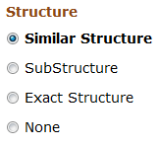

- Find the non-methoxylated version of 1d, 1d(-OMe)

What effect does removing the methoxy groups have upon the aromatic ¹³C NMR chemical shifts?

Finding Inorganic Crystal Structures - ICSD

The Lewis acid they found best to promote cyclodimersation was Tin(II) triflate, Sn(OTf)₂

What is the triflate anion?

- Find the chemical structure and systematic name of “triflate” on www.chemspider.com

The systematic name of triflate is: ……………..………………………………………………

How many triflate crystal structures are in the Inorganic Crystal Structure Database (ICSD)?

- Go to https://www.psds.ac.uk/ > ICSD
- “Advanced search and retrieve” > “Chemistry”
- Enter the systematic name of triflate from ChemSpider in the “Chemical Name” box
- Click “Run Query”

………………………. # triflate crystal structures in ICSD

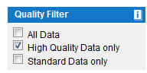
How many high quality triflate crystal structures are in the ICSD?

- Select “High Quality Data Only” in the “Quality Filter” box

……………………… # high quality triflate crystal structures in ICSD

To order the results by the column contents click on the column header.

What is the heaviest cation present in the list of high quality triflates?

……………………………………

What experiment did the structure for that entry come from?

- To view more information about entries, check the adjacent checkbox and “Show Detailed View”

- The tab “Experimental information” gives details of Radiation and Sample Type.

…………………………………………… Radiation type

…………………………………………… Sample type

Small molecule crystal structures – CSD

“Bioinspired Route to Indanes and Сyclopentannulated Hetarenes via (3+2)-Cyclodimerization of Donor-Acceptor Cyclopropanes”
One of the final indanes synthesised by the route in the paper 2c is active against both MCF7 and SiHa cancer cell lines:

2c

Dimethyl 2-({1RS,2SR,3SR)-3-(3,4-dimethoxyphenyl)-5,6-dimethoxy-2-[2-methoxy-1-(methoxycarbonyl)-2-oxoethyl]-2,3-dihydro-1H-inden-1-yl}methyl)malonate

From the paper’s supplementary information the crystal structure Refcode of 2c is HEQVAC

What is the crystal structure of 2c?

- Go to www.psds.ac.uk > CSD
- “Simple Search” > “Identifier(s)” > Query type = Refcode (entry ID)
- Type in the Refcode “HEQVAC”
- “Search”
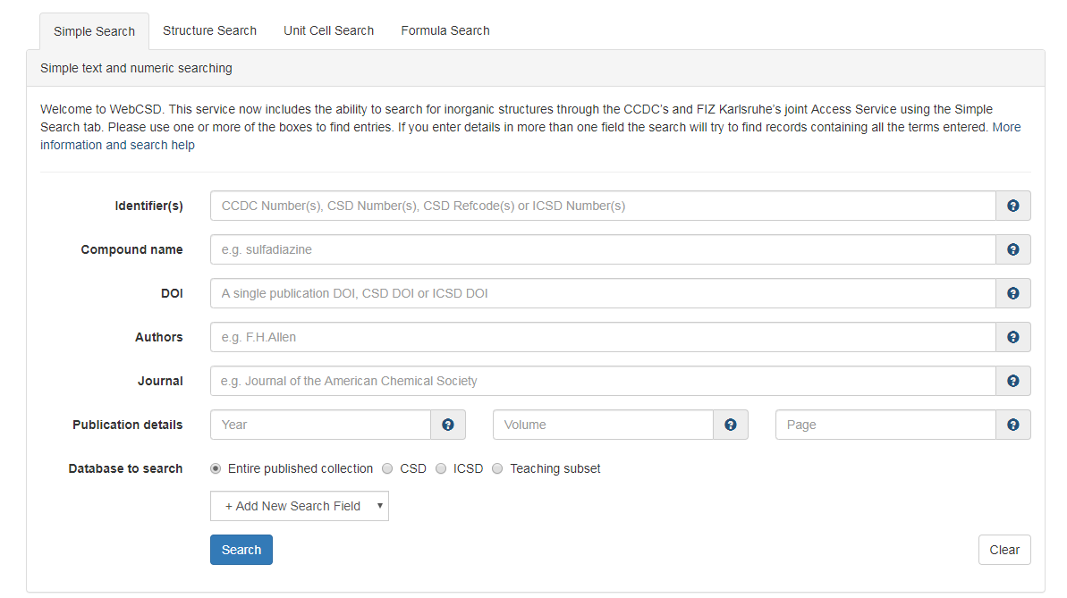
- You can manipulate the crystal structures in the Jmol window, measure distance, angles etc.
  - Left click = manipulate structure in 3D
  - Right click = options
  - Mouse wheel click (up/down) = zoom out/in
  - Mouse wheel click (left/right) = rotate structure
What is the average CO₂Me – CO₂Me C=O oxygen-oxygen distance in the crystal structure of 2c?

2c

WebCSD: Double click atoms and then another atom to measure distances in the crystal structure

Mercury: Picking Mode > Measure distance

( ………………… + ………………… + ………………… + ………………… Å ) / 4 = (……..…………… Å /4)

= ……………………… Å average

How many other structures are in the CSD with the same dimethoxy indane scaffold?

Dimethoxy indane scaffold

- Go to the “Structure Search” tab
- Select “Match Condition” to “Substructure”
- Draw the dimethoxy indane structure
- To ensure only methoxy results are returned (not ethoxy etc), left click on the carbon atom, and place this on the methoxy carbon
- Start search

…………………… # dimethoxy indane crystal structures in the Cambridge Structural Database (CSD)

